You have been tasked with creating a prototype air quality monitor and alarm prototype.  This will involve making use of OpenWeatherMap and PacketTracer.

Create an OpenWeatherMap account on <https://home.openweathermap.org/users/sign_up>

Complete the registration process by acknowledging the confirmation email.

For an overview of what is available, look at the available api's on <https://openweathermap.org/api>

For this prototype, you will use of the air pollution api on <https://openweathermap.org/api/air-pollution>

Air quality metrics

Pick one of the following metrics.  In a text note on the Packet Tracer workspace, briefly explain your reason for choosing the metric and specify what a safe threshold level is.  You must reference the threshold value of the metric.

* Carbon monoxide (CO)
* Nitrogen monoxide (NO)
* Nitrogen dioxide (NO2)
* Ozone (O3)
* Sulphur dioxide (SO2)
* Ammonia (NH3)
* particulates (PM2.5)
* particulates (PM10)

By using the latitude and longitude of Ara's Madras street campus which is on 130 Madras Street, Christchurch, 8011, New Zealand, configure SBC1 to periodically obtain the air pollution data for that site. SBC1 uses IPv4 to get the data from OpenWeatherMap.

LCD messages

Once the data has been received, display the Air Quality Index value on the lcd.  If the alarm is not active, display the message 'Status: Normal'.

If the alarm is active, display the message 'Status: alarm'.

The air quality index is just displayed, it is not a metric.

If your chosen metric exceeds the threshold, SBC1 must send the instruction to SBC2 to start the alert process by flashing the led's.  When the level drops below the threshold, SBC1 must send the instruction to SBC2 to stop the flashing sequence.

Once instructed by SBC1, they must flash in an all on, all off sequence.

The SBC's communicate using wireless via the AP.

The SSID of the router must be FactoryFloor, the WPA2-PSK key must be PT53cr3t

IPv4 addresses.

You have been given the network 192.168.0.0/28 /28 has been allocated so more alarms can be deployed later.  Router1 must use the first address in the range, SBC1 must use the 2nd address in the range.  SBC2 does not use IPv4.

IPv6 unicast addresses

As the environment at the premises has moved to IPv6, communication between SBC1 and SBC2 must be done using IPv6 only.

You have been given the IPv6 network 2001:DB8:ACAD::/48

The environmental devices within the institute are going to use the first subnet.

The first available address on the subnet has been reserved for the router interface.  The router is not allocated an IPv6 address.

SBC1 and SBC2 must must use the second and third addresses on the IPv6 subnet respectively.

IPv6 Link local addresses.

The first available link local address has been reserved for the router interface. The router is not allocated an IPv6 address.

SBC1 and SBC2 must must use the second and third link local address respectively.

SBC1 must send the 'StartAlarm' and 'StopAlarm' instructions (as text) to SBC2 using IPv6 on port 5000.  As this is important traffic, a reliable transport layer protocol must be used.

Hardware requirements

* Two SBC's
* One WRT300N router
* 5 alarms

Suggested layout

Normal condition

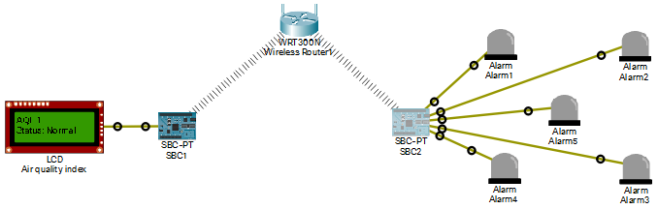

Alarm condition

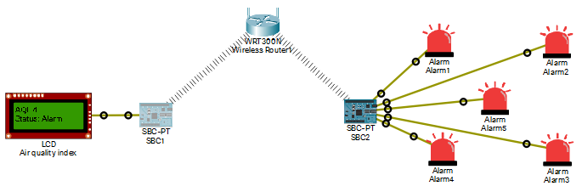

Hints.

* Make use of a web browser or Postman to see the data that is returned from OpenWeatherMap.  
  Look at the type of object that is generated by json loads.
* Make use a of json formatter such as <https://jsonformatter.org/> to clearly display the json data returned from OpenWeatherMap.
* Make use of the Webex example code from the previous lab but use http.get(url) rather than http.getWithHeader(url, header)  
  You will need to make use of realhttp to allow PacketTracer to access the data on OpenWeatherMap.
* <https://openweathermap.org/appid> says the update rate is every 10 minutes so don't poll every few msecs.

Deliverables

Upload the PacketTracer file along with a short document explaining your choice of metric and threshold value.